MIS 6308

Fall 2017

Assignment 1

Consider the food delivery service www.doordash.com. Please go over the functionalities offered doordash. You do not have to place an order, but you will have to go through all the steps until just before placing the order. Examine the data and process steps and answer the following questions.

**Question 1: (5 Points)**

One important class you should be able to identify is restaurant. Show at least 10 possible attributes maintained by door dash for this class.

Ans 1:

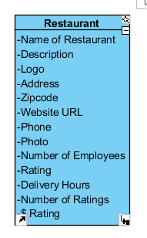

**Question 2: (5 points)**

1. Suppose you want to model the different types of restaurants using generalization. Show how you would model it. Please show at least two different sub types, and attributes for these sub types.

Ans 2(a):

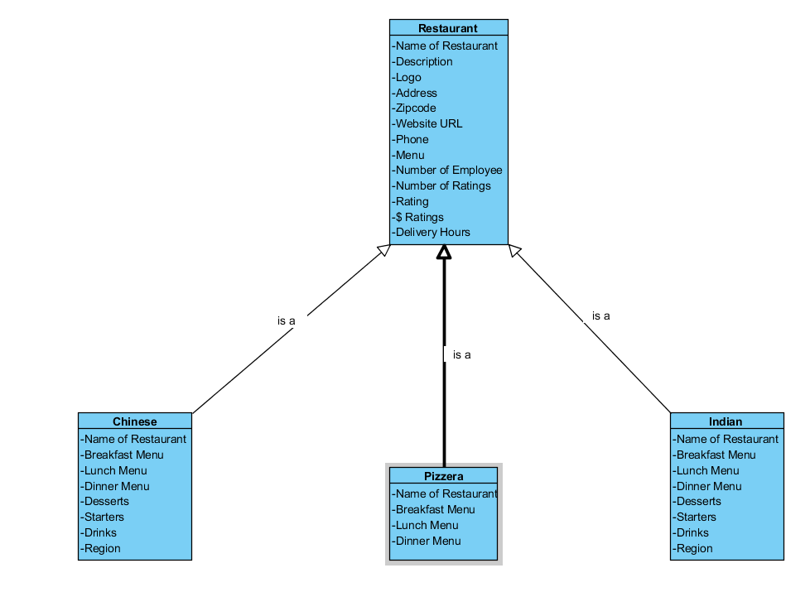

**Corrections to be made to the above: Delete Name of Restarant and all attributes except Region in the sub classes. So, only Chinese and Indian will have only one attribute Region. Pizzeria will not have any attribute.**

1. One of the main data relevant for each restaurant is the menu. Show you can model the menu of a restaurant using aggregation.

Ans 2(b):

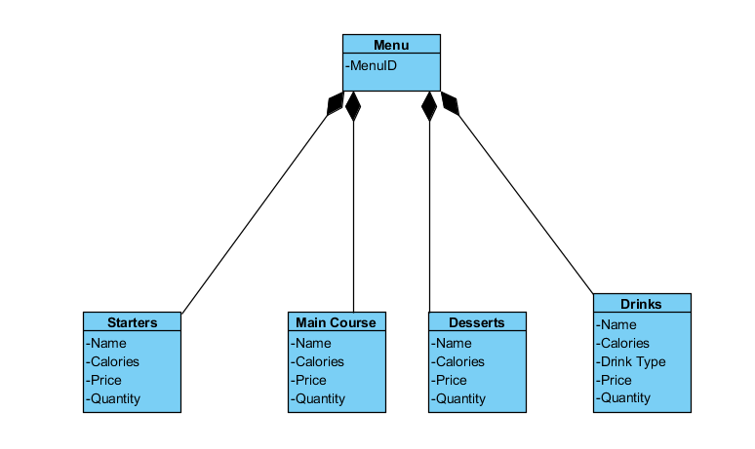

**Question 3: (5 Points)**

Consider the following classes for Doordash.

|  |
| --- |
| Order |
| -Order#  -OrderDate  -OrderTotal |
| +PayDriver |

|  |
| --- |
| Single Order |
|  |
| +Deliver Order |

|  |
| --- |
| Group Order |
| -Group Size |
| +Send Link to Group  +Deliver Order |

In the above diagram,

1. Which attributes are inherited by (i) Order? (ii) Group Order? (iii) Single Order?

Ans 3(a):

(i) Order is the parent class. So, it doesn’t inherit any method.

(ii) Group Order inherits attributes – ‘Order#’, ‘OrderDate’, ‘OrderTotal’

(iii) Single Order inherits attributes – ‘Order#’, ‘OrderDate’, ‘OrderTotal’

1. Which methods are inherited by (i) Order? (ii) Group Order? (iii) Single Order?

Ans 3(b):

(i) Order is the parent class. So, it doesn’t inherit any method.

(ii) Group Order inherits method – ‘Pay Driver’

(iii) Single Order inherits method – ‘Pay Driver’

1. Which element in the above diagram is an example of polymorphism?

Ans 3(c):

‘Deliver Order’ method is an example of polymorphism. It is used in both the classes- ‘Group Order’ and ‘Single Order’. Both the methods perform different operations depending on different parameters passed.

1. What is the interface for Group Order?

Ans 3(d):

‘Send Link to Group, Deliver Order, and PayDriver’ are the interfaces for the class ‘Group Order’.   
 Because both operations are available to the public.

**Question 4 (5 points)**

Create the following models for the ‘Place Order’ process used by Doordash using BPMN notation.

1. Process Diagram with appropriate pools

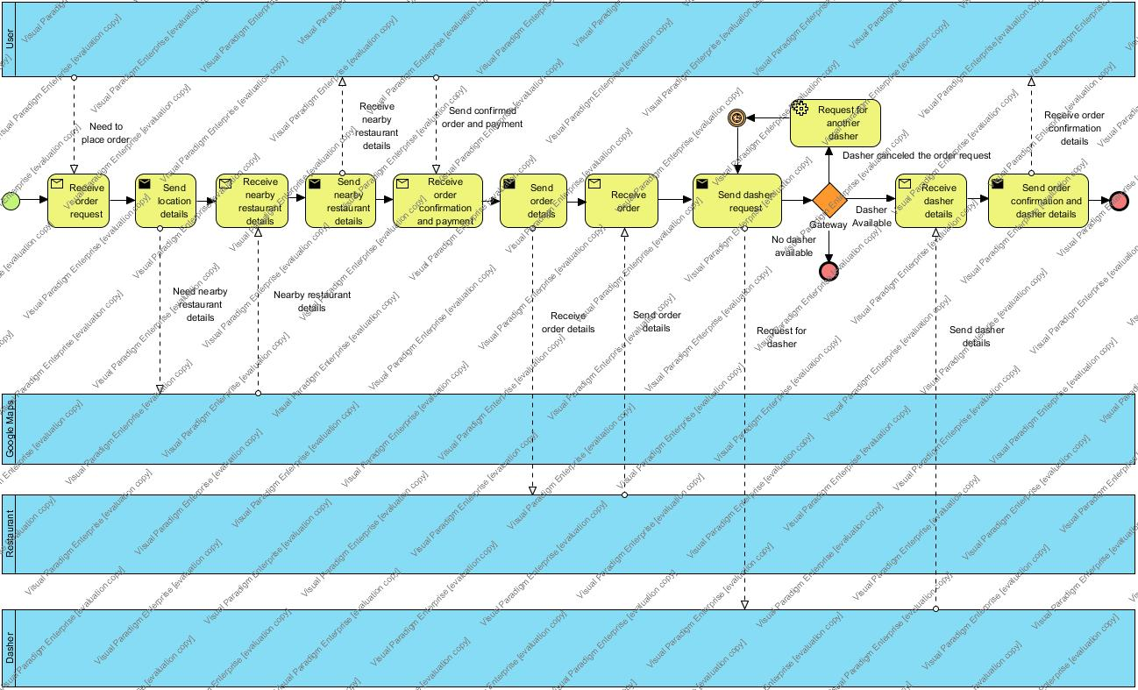

1. A choreography diagram with pools and processes within those pools

